Create a Gourd Bird House Or Gourd Bird Feeder

Saturday, September 6, 2014 9am to 3pm
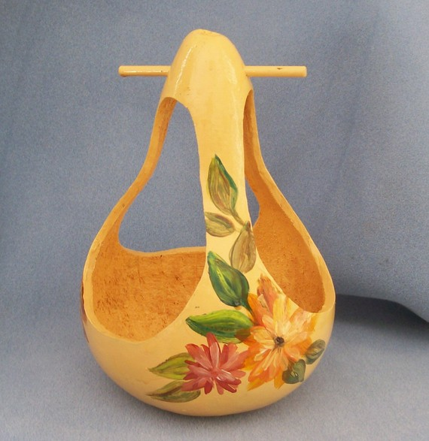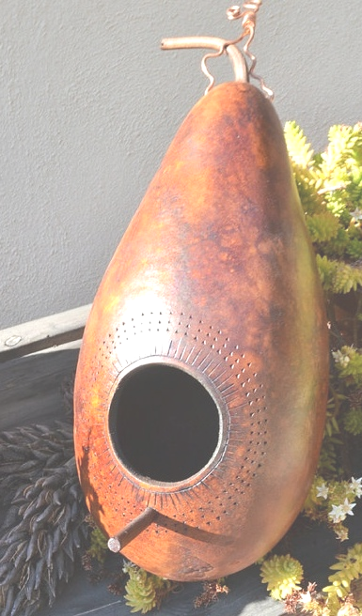

Gourds make excellent birdhouses and bird feeders. In this class you will create a colorful birdhouse or birdfeeder. You will also learn the basics of cavity and hole-size requirements for different species of cavity-nesting birds so you attract the birds you like.

This class will be taught by lavenpine creative consulting instructors, Kathy Badrak and Karen Osland.

Class cost is $35 per person. Cost includes gourd and all materials.

Class size is limited. To reserve your space please call (805) 736-3743 or e-mail lavenpine@yahoo.com Checks, payable to lavenpine consulting, should be mailed to 1383 San Miguelito Road, Lompoc CA 93436. You can also pay using Paypal on our website – www.lavenpine.com

Upon receipt of your payment a confirmation with class location details will be sent to you.

Class Registration and Cancellation Policy
Class fees should be paid as soon as possible after registration. Your space will be held for a reasonable length of time to allow you to mail your check in payment of the class. Your space in class is NOT confirmed until your payment has been received.

